**Step 1: Deleting any previous tables with the same name**

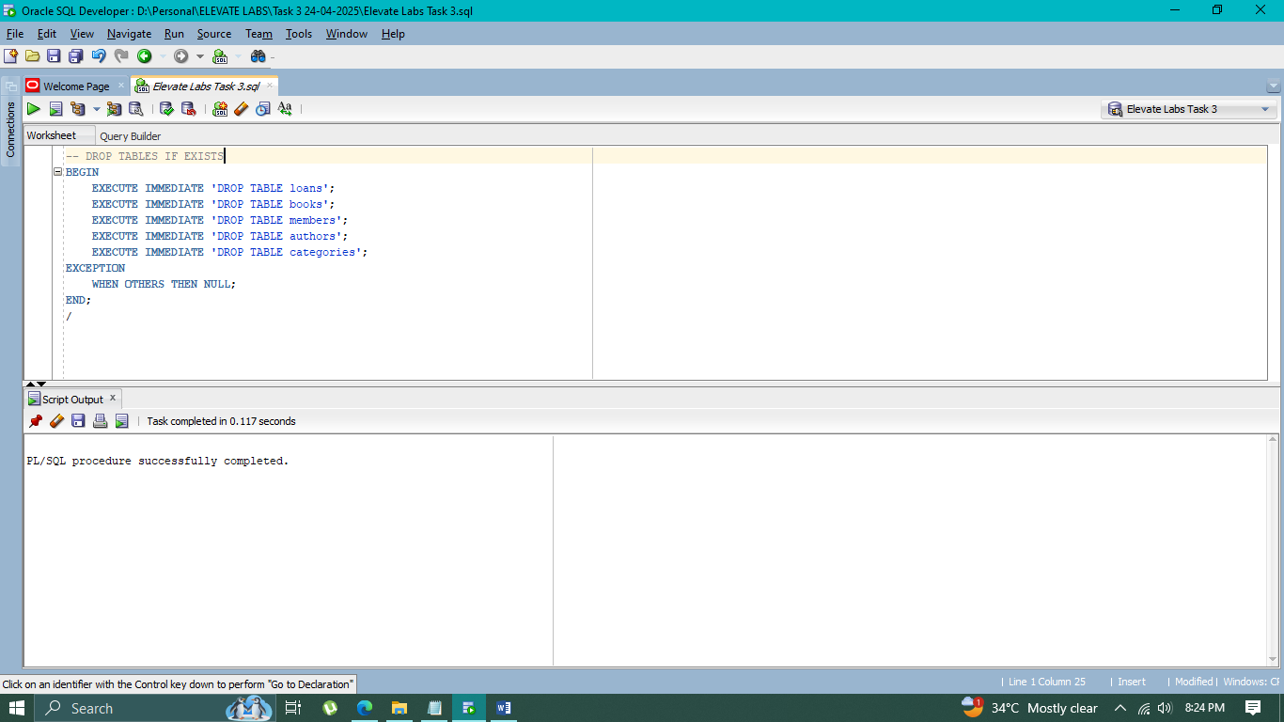

**Step 2: Creating Tables:**

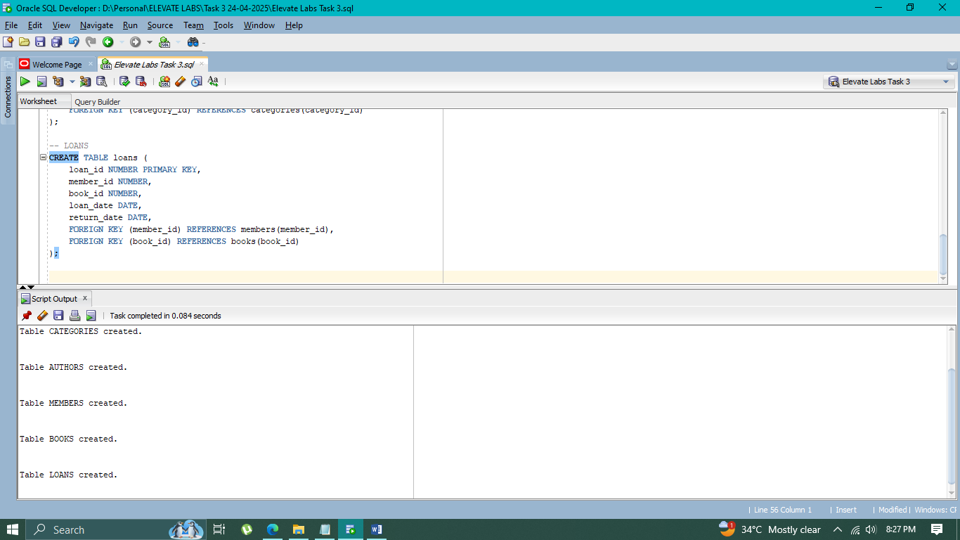

**Step 3:**

* **Inserting values into “Categories”**

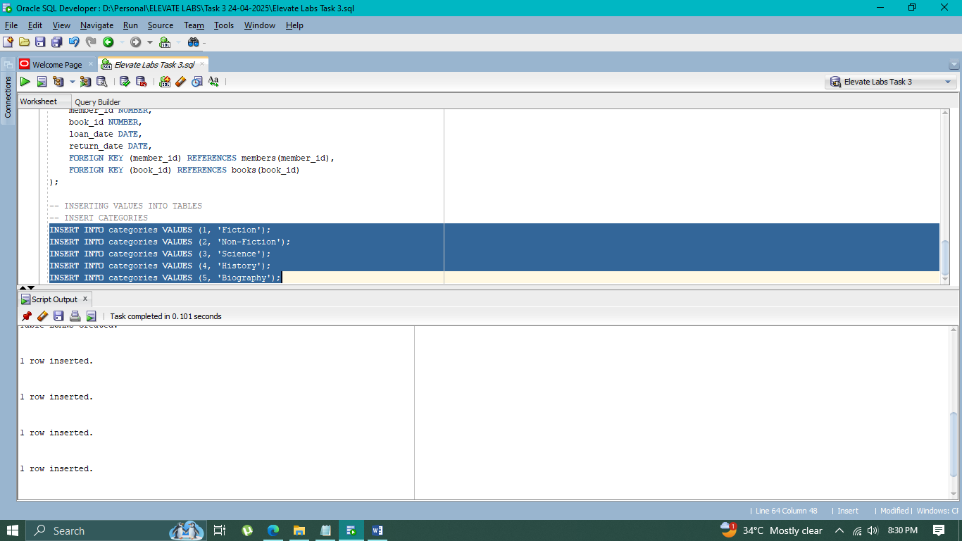

* **Inserting values into “Authors”**

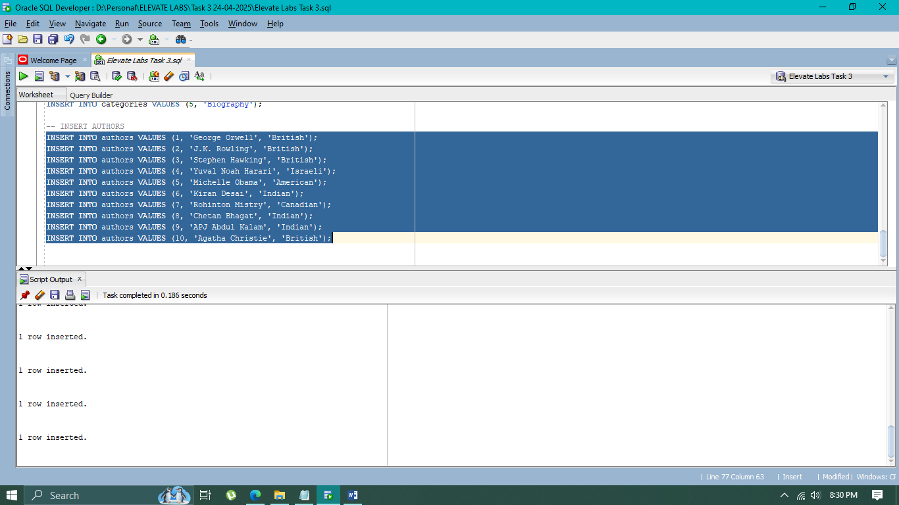

* **Inserting values into “Members”**

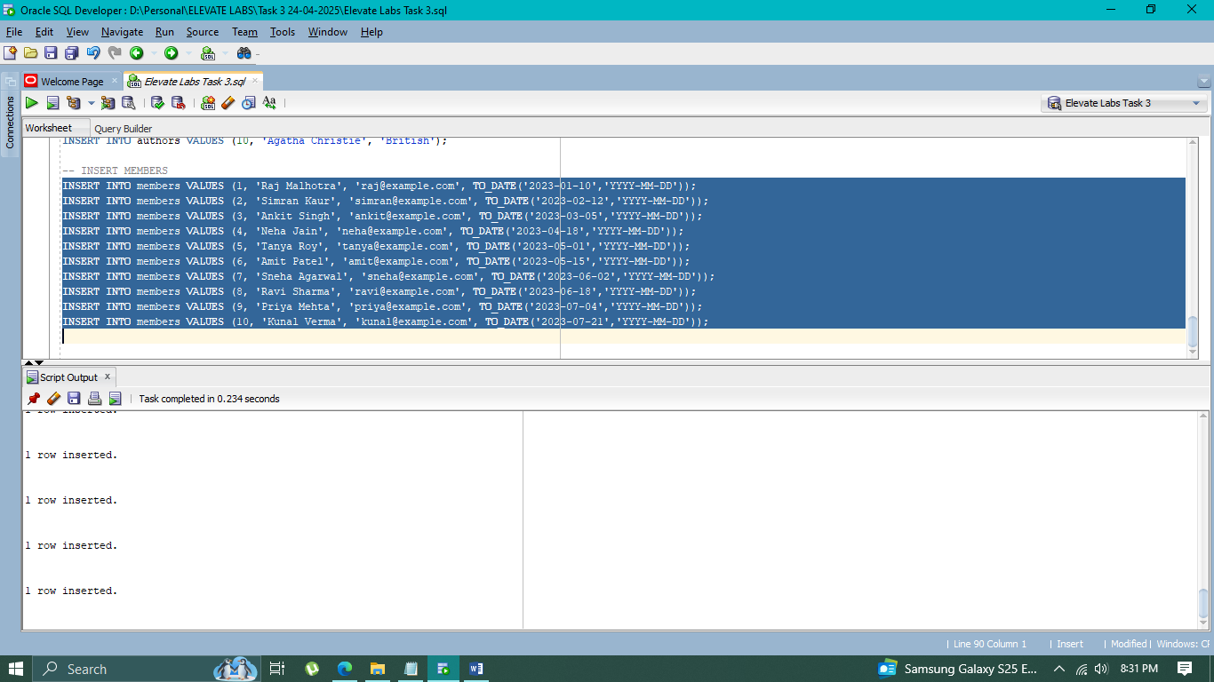

* **Inserting values into “Books”**

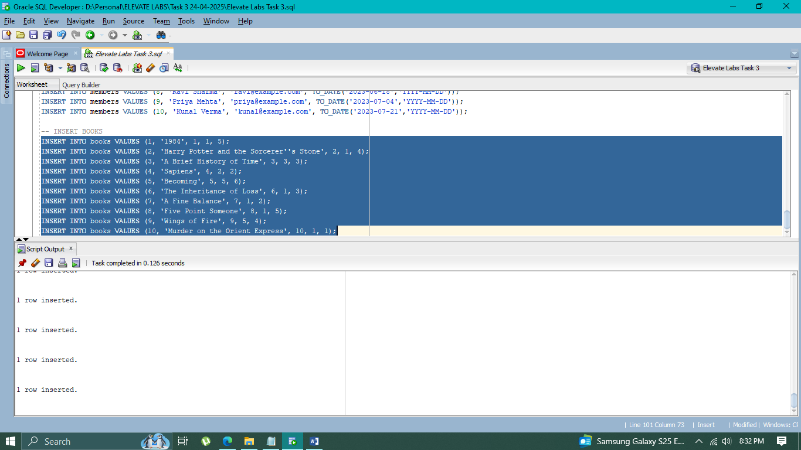

* **Inserting values into “Loans”**

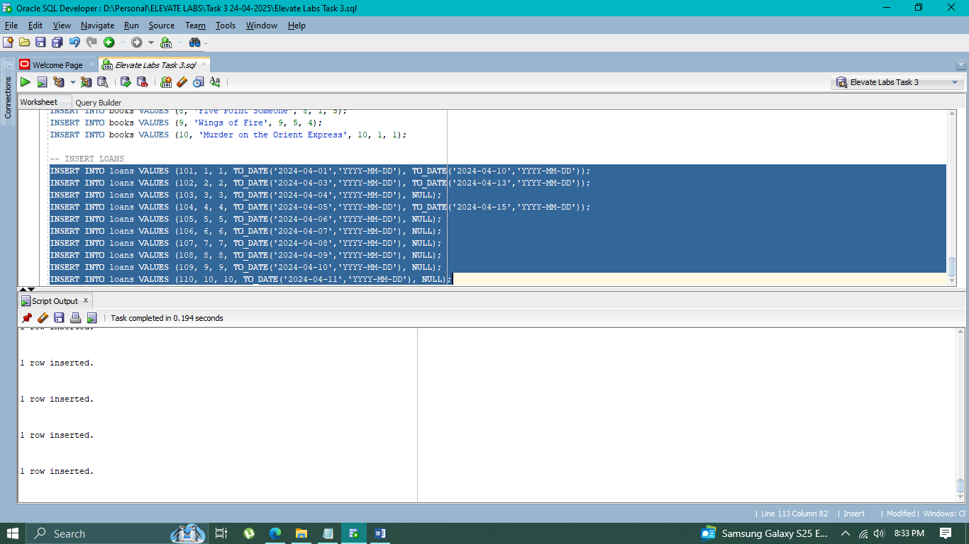

**Step 3: Checking if tables are created properly**

* **Books**

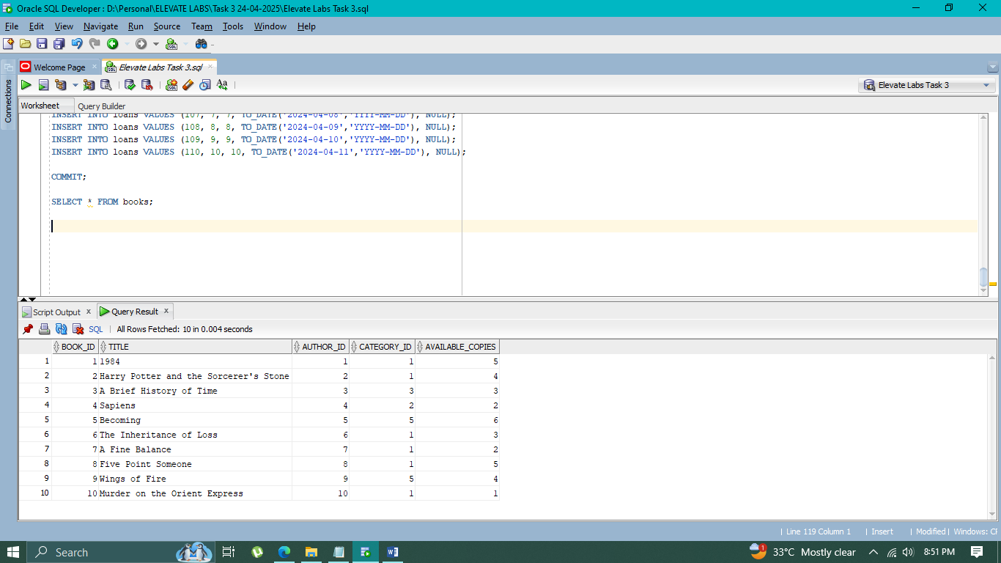

* **Authors**

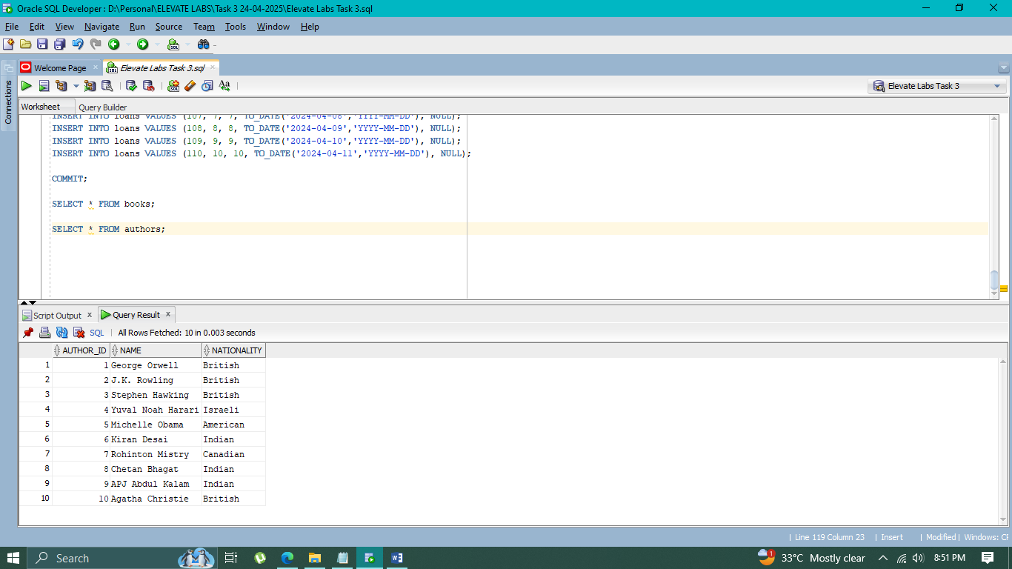

* **Members**

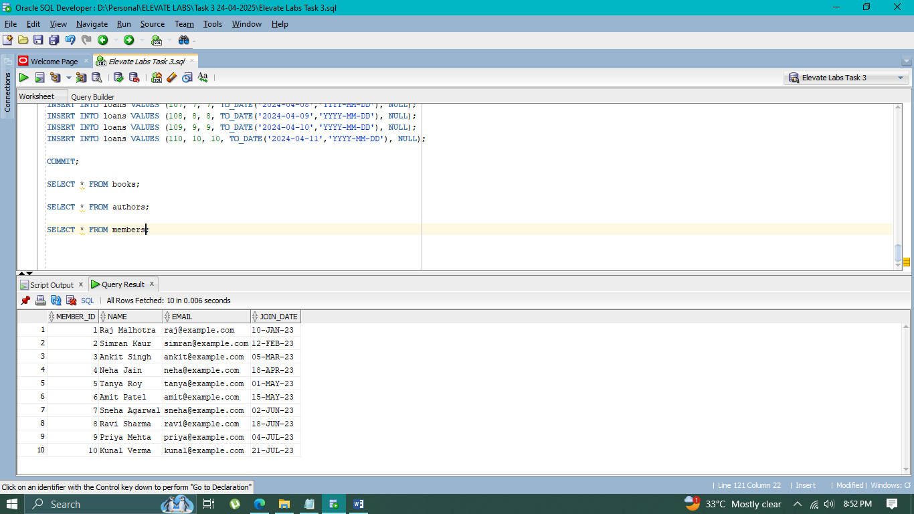

* **Loans**

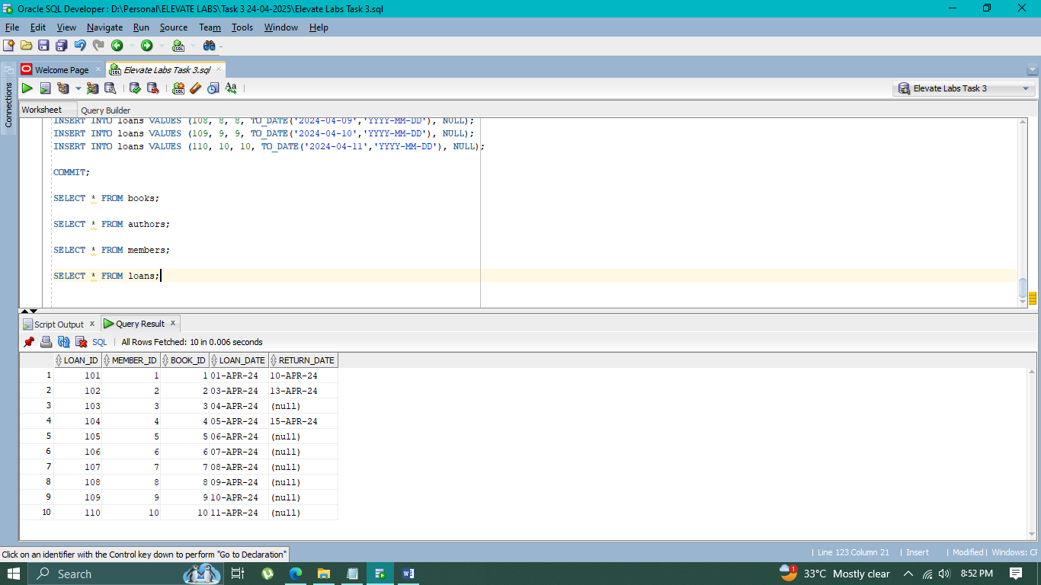

* **Categories**

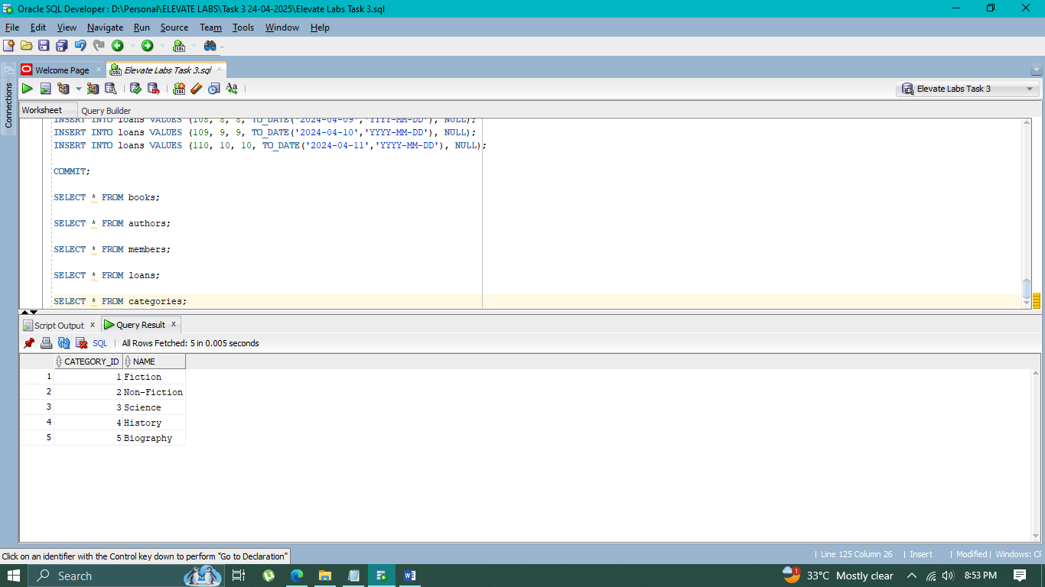

**Step 4: Queries**

**1. List all books with their author names and categories**

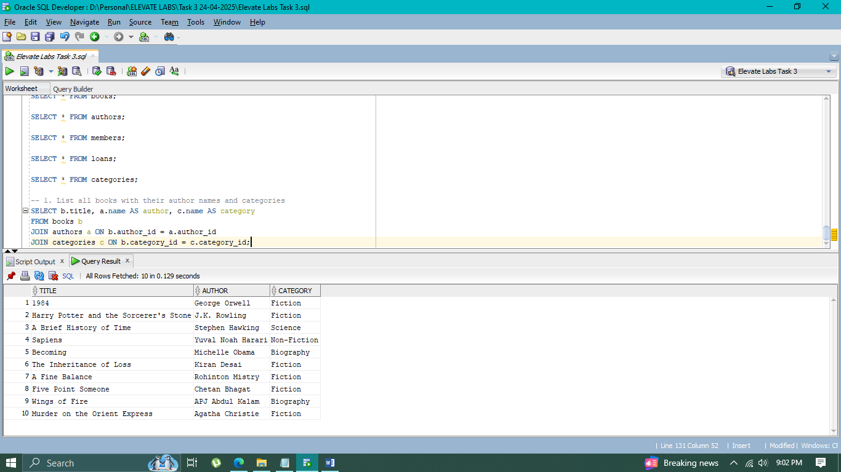

**2. Show members who have not returned books**

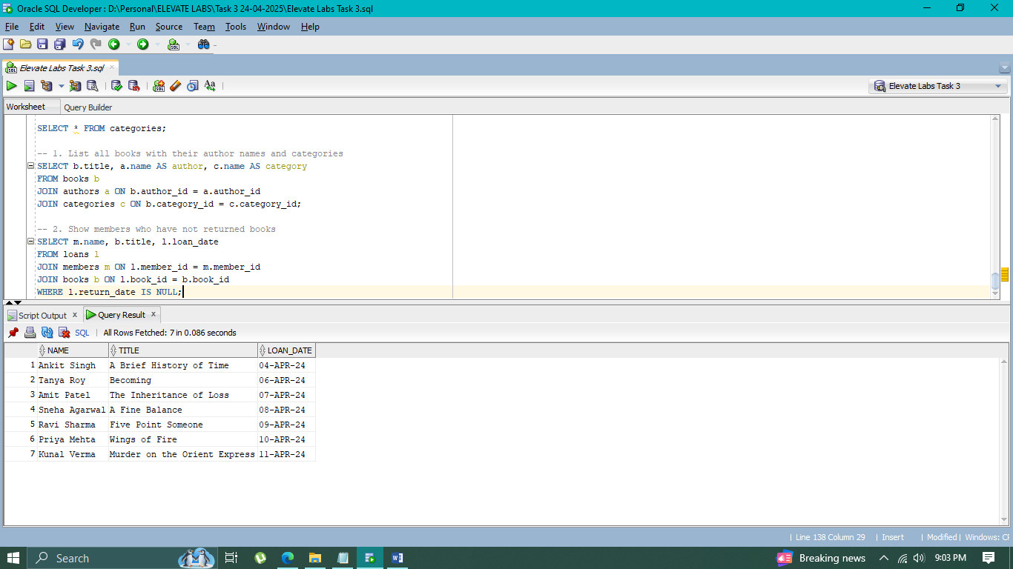

**3. Count how many books are in each category**

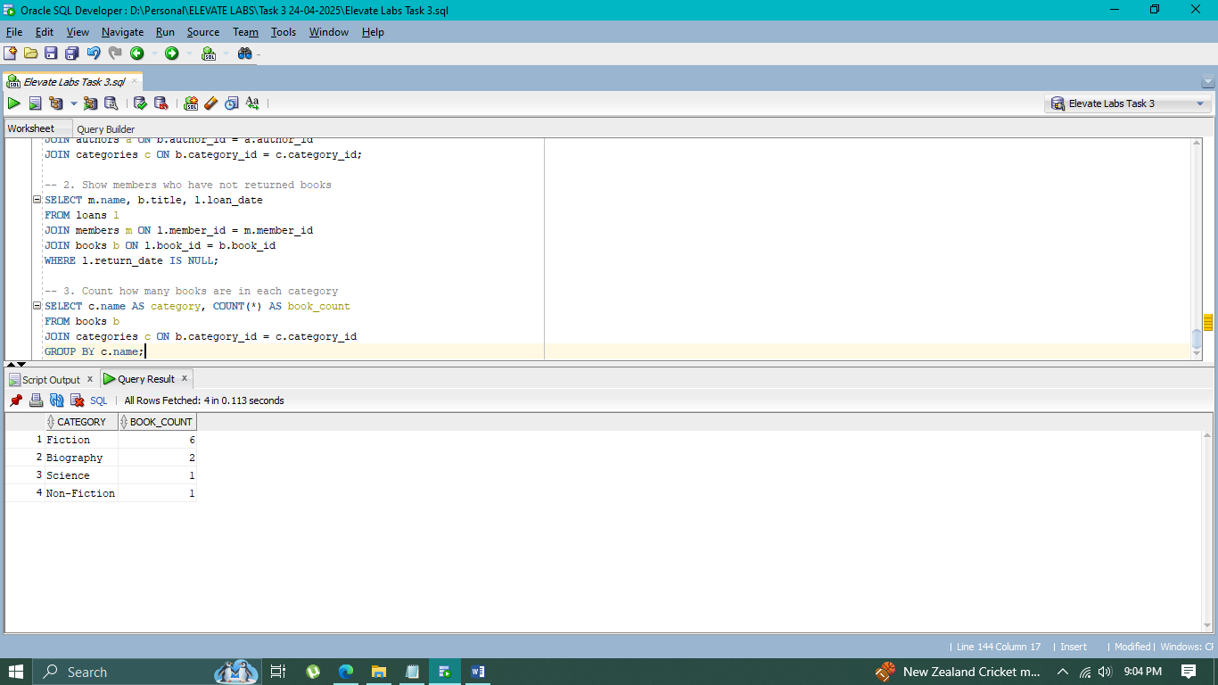

**4. List overdue loans assuming today is '2024-04-20'**

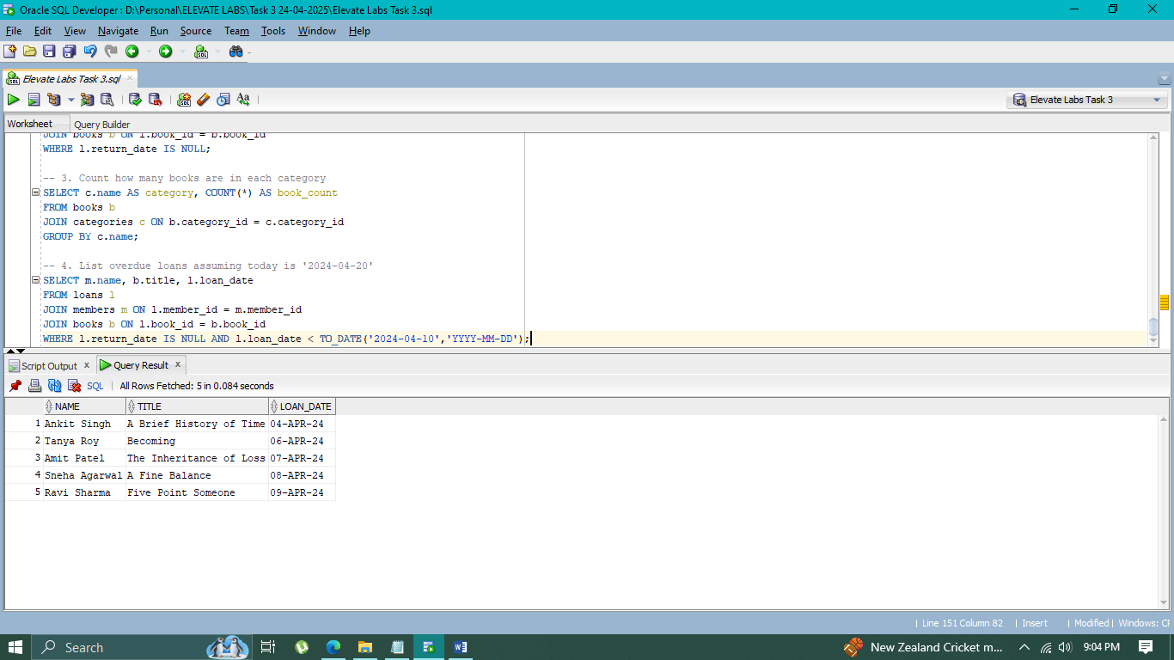

**5. Find which authors have more than 1 book in the library**

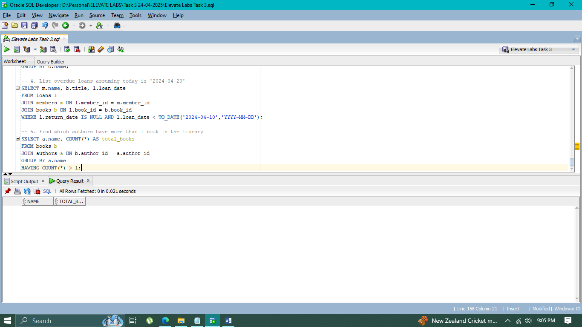

**6. Books borrowed by each member**

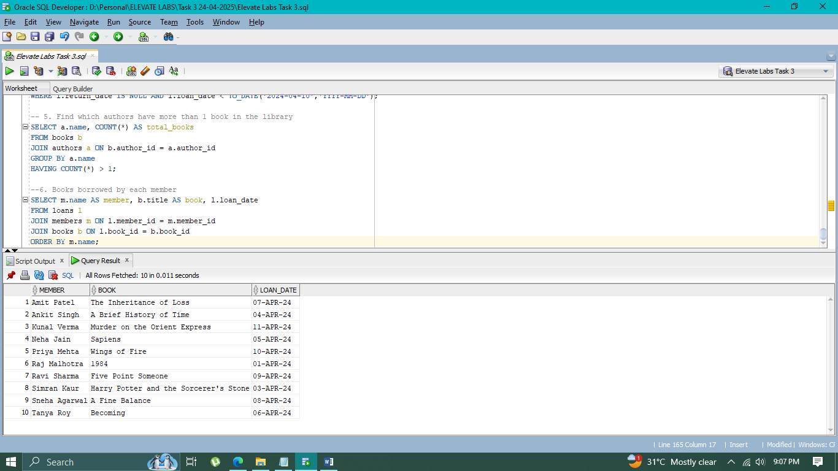

**7. Book count per author**

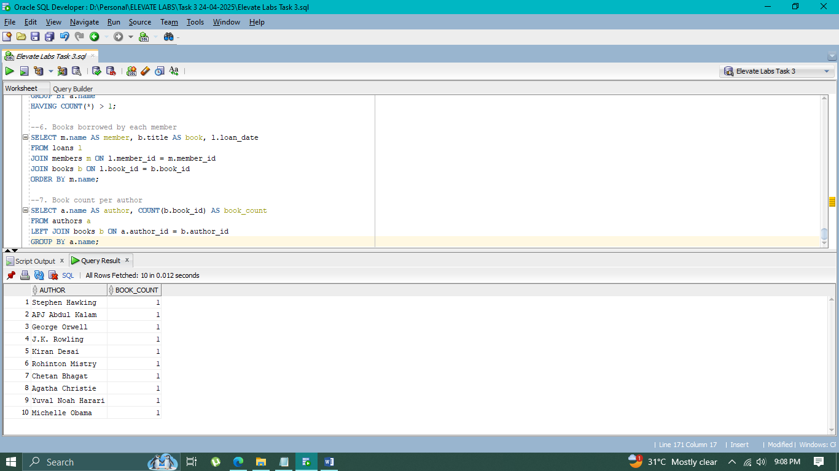

**8. Members who borrowed books from the "Science" category**

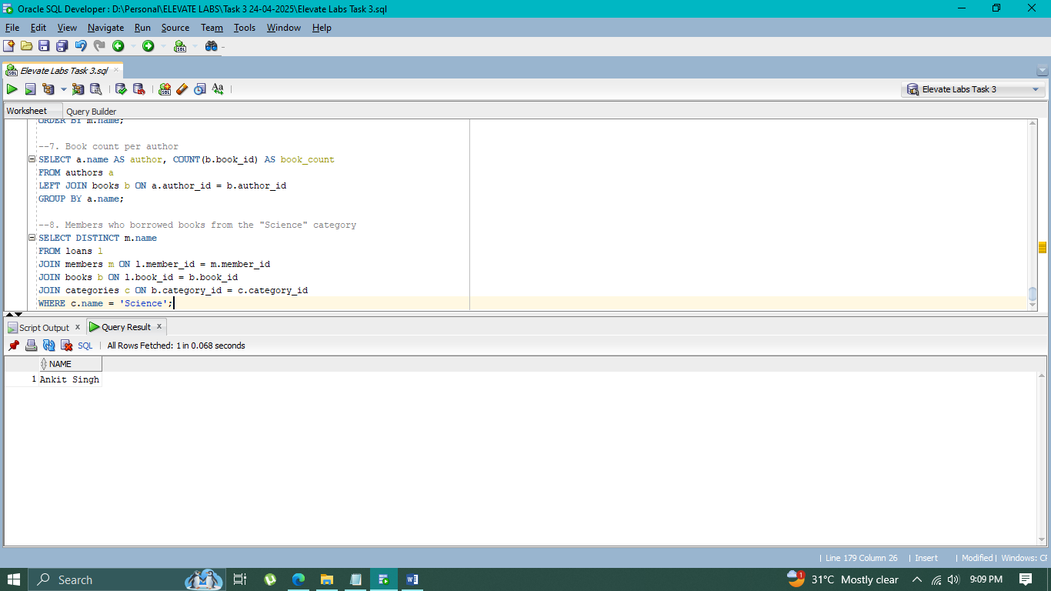

**9. List members who have borrowed more than 1 book**

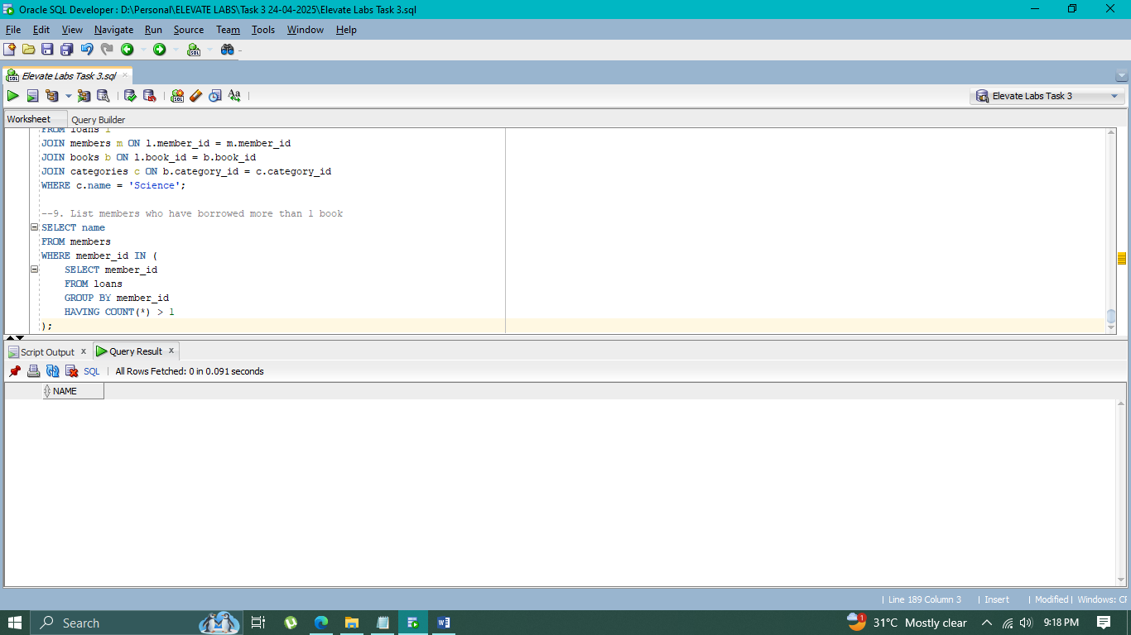

**10. Find the book(s) with the least number of available copies**

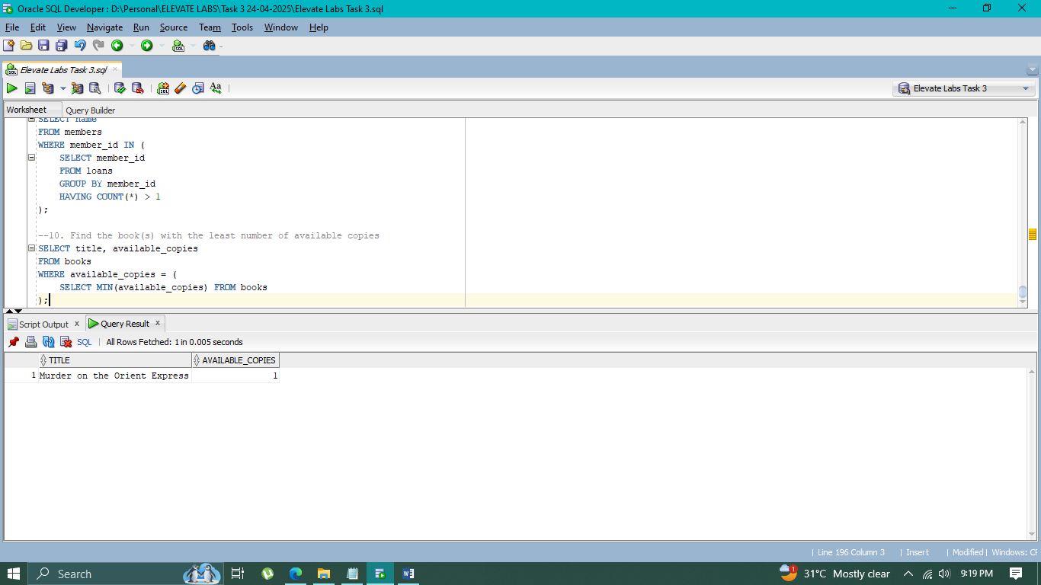

**11. Authors whose books have never been borrowed**

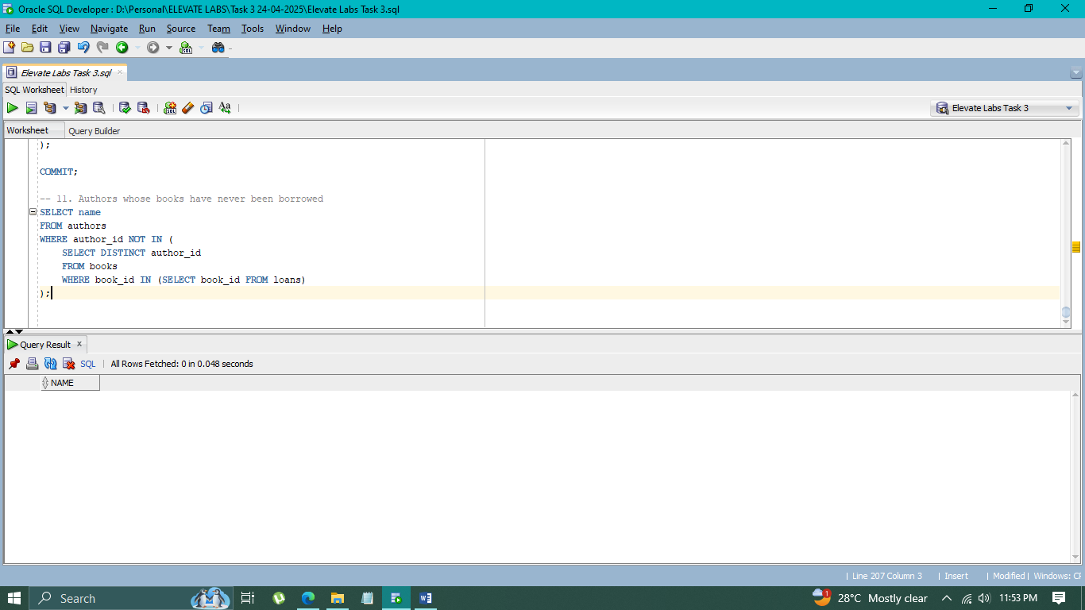

**CASE Statements Practice**

**12. Show loan status for each book (Returned / Not Returned)**

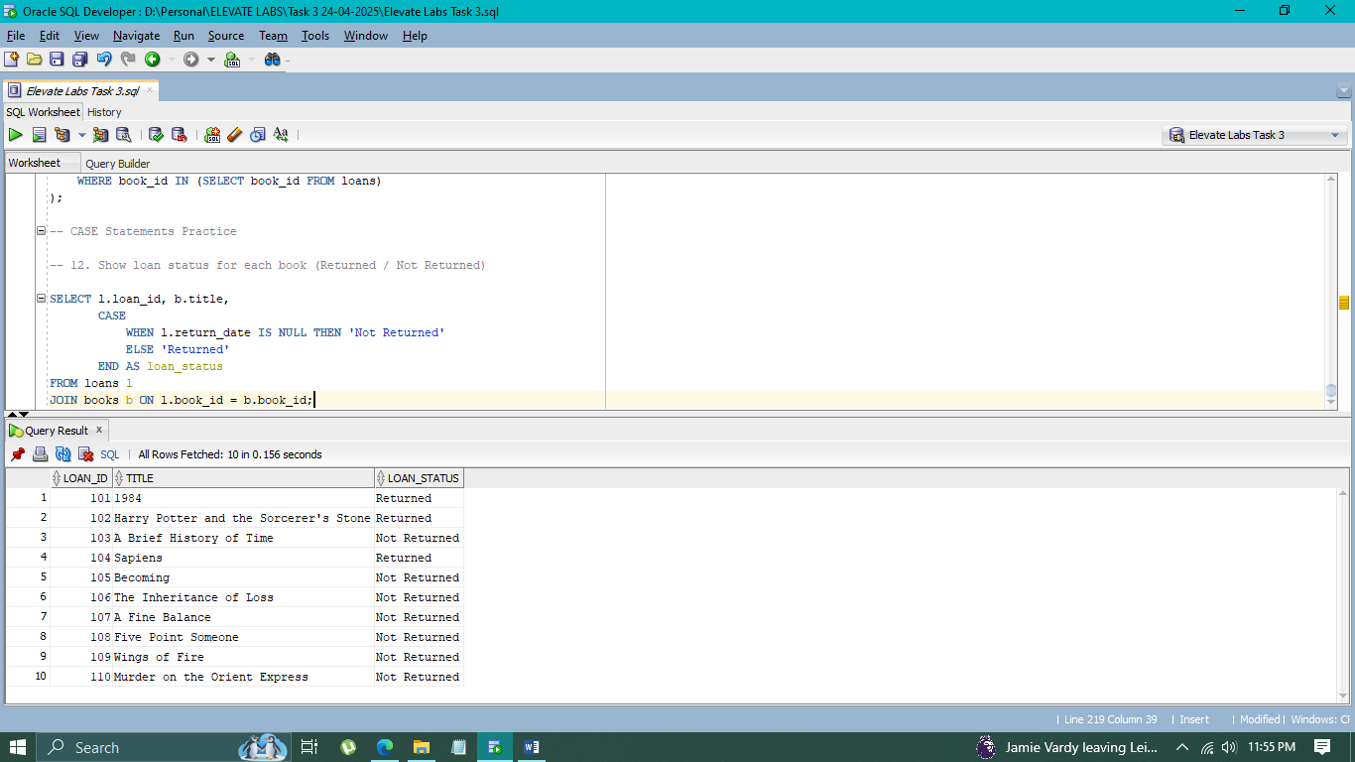

**13. Categorize members based on number of books borrowed**

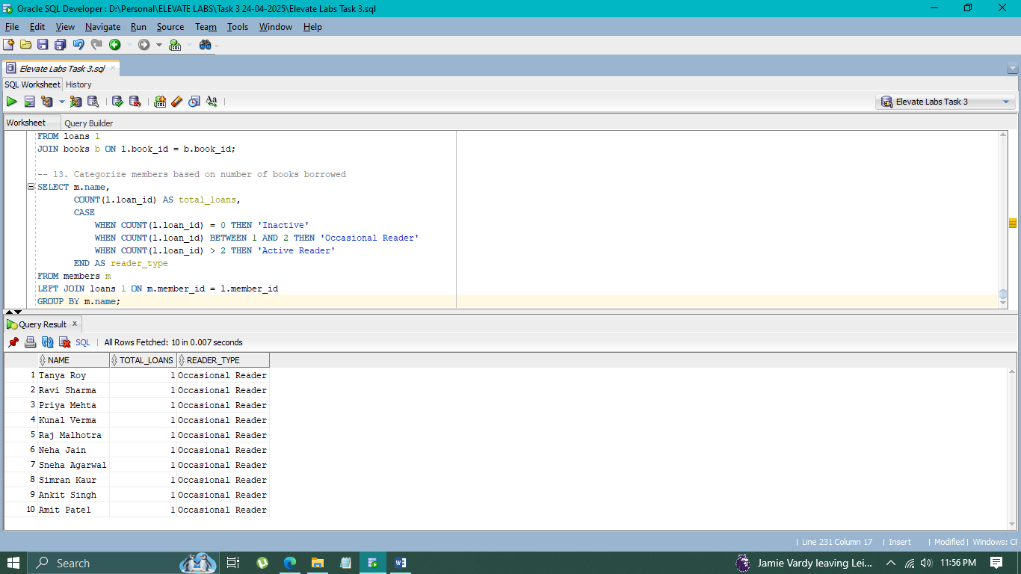

**14. Flag books with low stock**

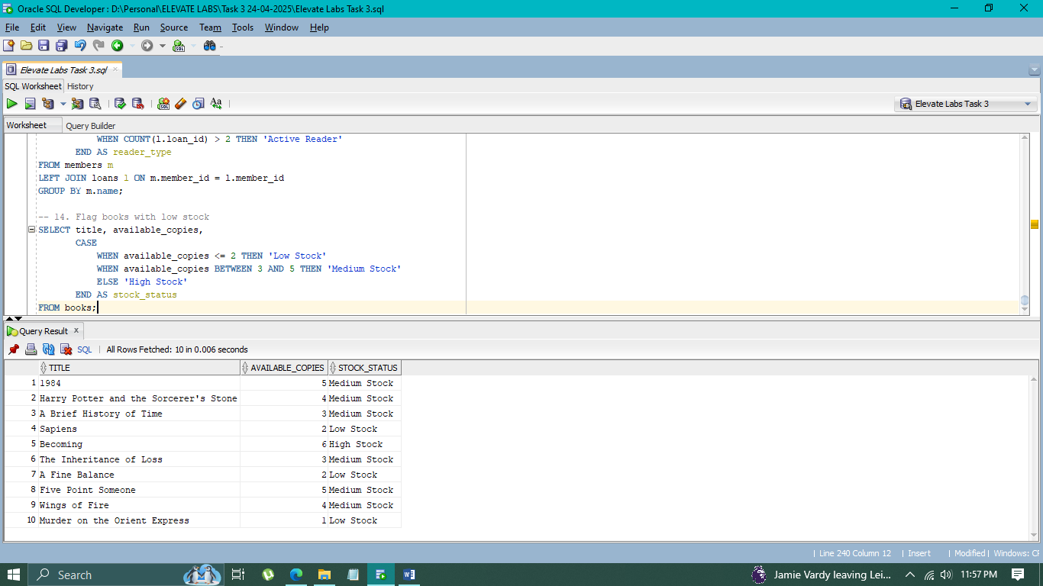

**VIEW Statements Practice**

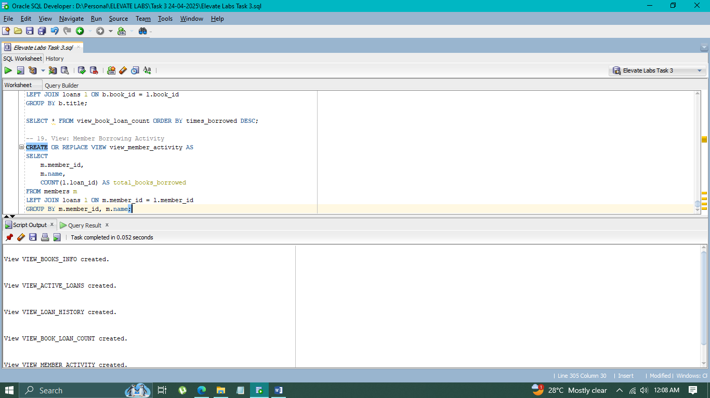

**15**. **View: Books with Author and Category Info**

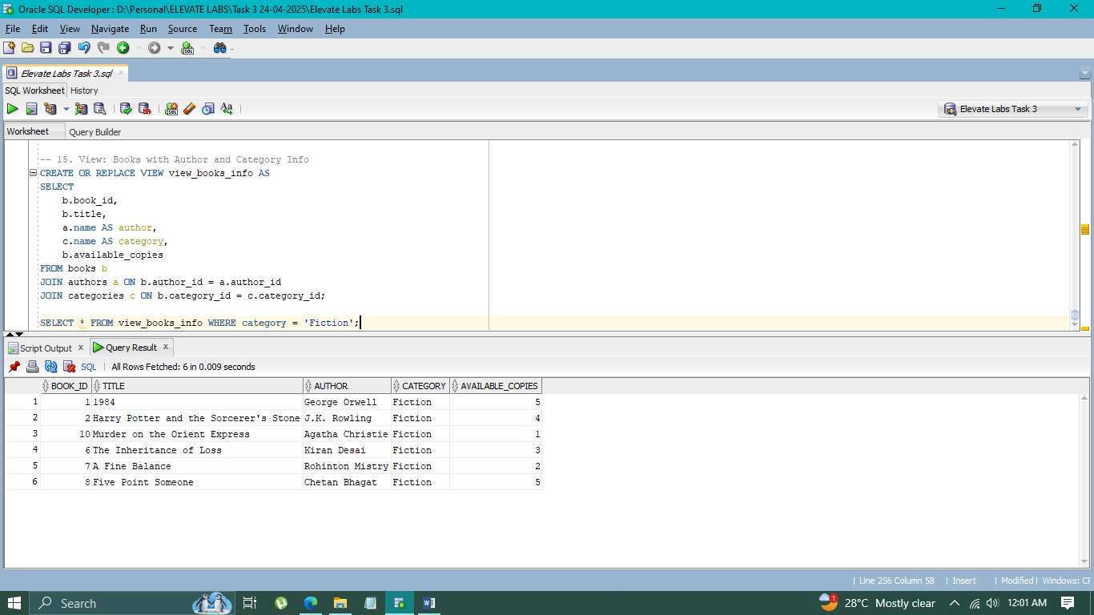

**16. View: Active Loans (Not Yet Returned)**

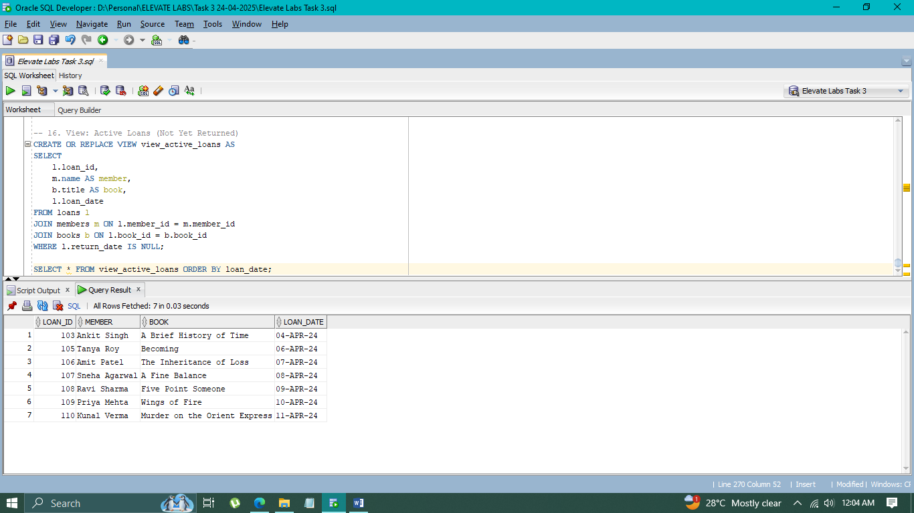

**17. View: Loan History Summary**

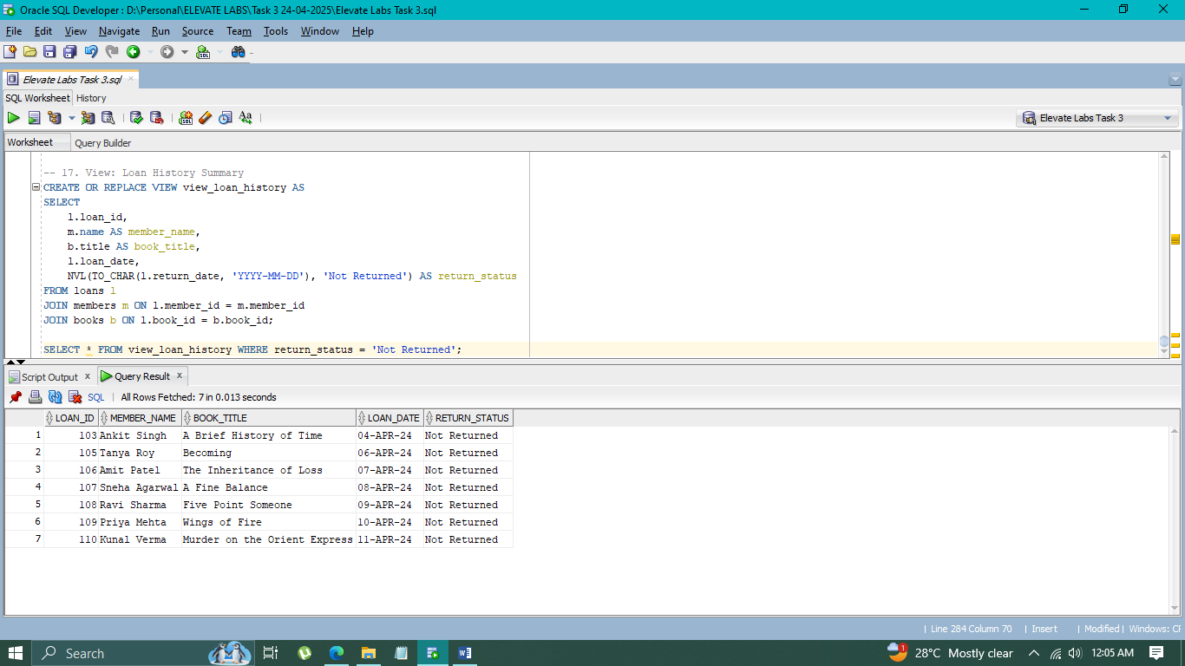

**18. View: Book Loan Counts**

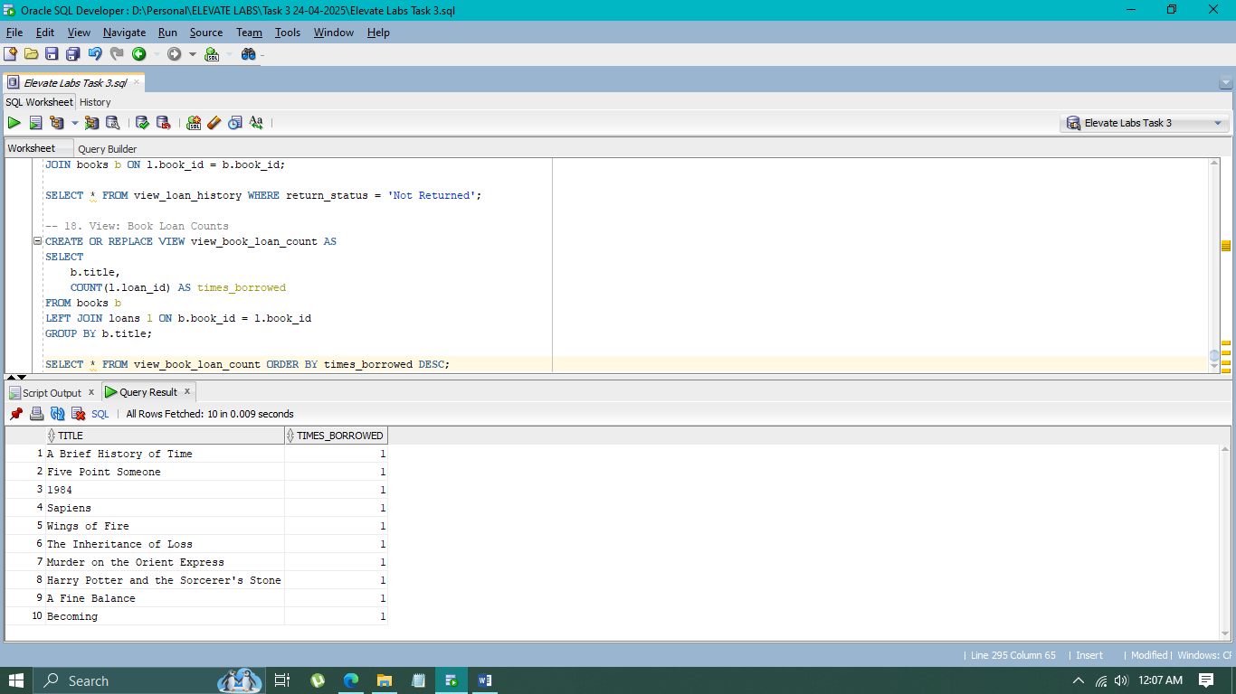

**19. View: Member Borrowing Activity**

